Selamawit Teshome

Project 2: Website Proposal

April 23, 2023

**Client and Topic**

The project I am planning to work on is The Change Request Website. The website will support a government agency I am currently supporting as a contractor. I chose the solution because the change request was sent via email and there are problems such as issues not being addressed on time, requests missing, and not having a centralized record of the request and the expected expenses associated with the project.

**Development Process and Engagement**

I will develop my department's Change Request Management website, which I currently support as a contractor. The development process involves managers, stakeholders, IT Staff, and project managers. The development process will include regular meetings, collaborative design and development, request gathering, client testing, and feedback. There will be continued testing, client training, and project review throughout the development process. The collaboration of the team effort will ensure their requirements are met and reduce rework.

**Testing:**

Testing is crucial in the helpdesk website development process; comprehensive testing ensures its reliability, functionality, and security. First, I would include the most used web browsers, such as Chrome, Firefox, and Edge, to ensure co-functionality, usability, compatibility, and performance testing, to identify and fix any issues or bugs. Then, for the website to work, I would follow comprehensive functional testing, compatibility testing, responsive testing, content testing, performance testing, security testing, and accessibility testing.

**Description:**

The primary purpose of the change management website is to allow users to submit, track, and manage change requests for large-scale projects that involve a wide range of stakeholders. For example, I'm considering the government agency I am currently supporting. Further, the application allows users to modify submitted change requests, track the progress of requests, capture status updates and broadcast comments or revisions, and notify users when updates or changes are made to requests.

The intended audience for the change request website is.

* Managers and stakeholders: decision-making group reviewing change request information, assessing impacts, and tracking progress.
* IT Staff: Technical groups such as system administrators, developers, and support responsible for making the changes.
* End user: users who submitted change requests.
* Project managers: responsible for managing and tracking the request and its associated cost.

Overall, power users for the change request application are decision-making people, project managers, application integrators, implementation staff, and requesters.

**Growth and Maintenance:**

The change request website is expected to grow by adding user feedback, integrating with other tools, offering mobile access, and adapting to change. For the website to function well and for anyone to support it, there will be documentation for every configuration, including comments and user guides. The other way is implementing version control to track changes and collaborate effectively with a team. The Maintenance and monitoring of the website will be ongoing daily, updating and applying patches will be done regularly and as needed, user account management will be continued, and as required, data backup and restoration regularly and as needed, and compliance check will be performed periodically, user experience a functionality will be in place ongoing as it sets improvements and feedbacks.

**Organization:**

The Change Request Website will feature a homepage with clickable options for easy navigation to different pages, including user registration and login pages, application change request form, document change request form, training and user guidance, and a newsletter. The website content will be organized using straightforward navigation with dropdown options, logical categorization, and search functionality to facilitate easy access and retrieval of information. Sub-topics will include tracking change request status, change request master log, and document change master log. Users can access the application change request form, which will have the required fields for submission, and a confirmation notice will be sent to their email address upon submission. Similarly, the document change request form will follow a similar process. The website will also have dropdown options for the Application Change Request Master log, application change request dashboard, Document Change Request Master log, and document change request dashboard. Users can register for a new account or log in as existing users from the user registration page. The website will strive to provide a user-friendly interface for efficient change request management.

**Homepage Wireframes**

**User Login and Registration Wireframes**

**

**The Chang Request Management Flowchart**

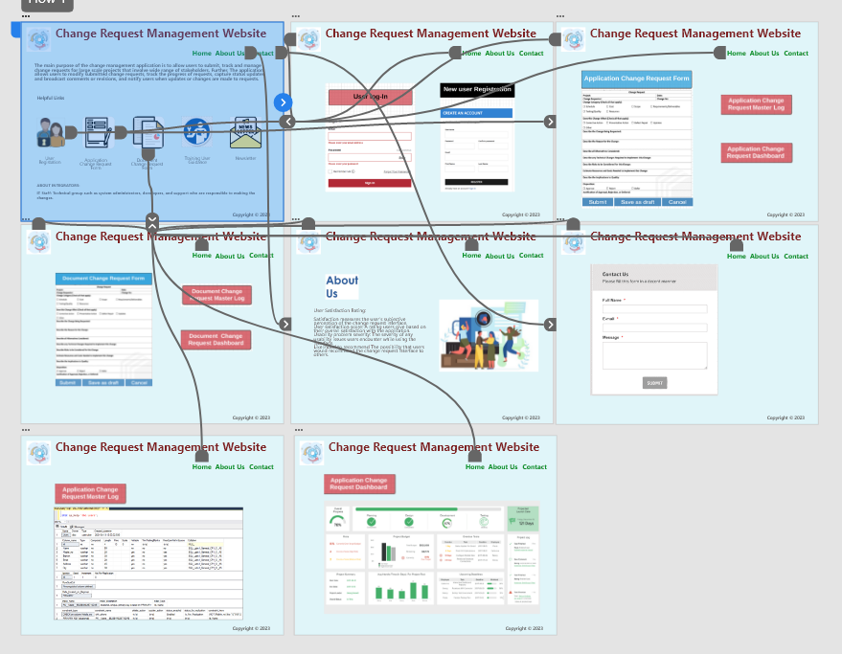

**Security:**

The change request management website will be secured with password protection mechanisms to ensure the confidentiality and integrity of sensitive commerce-related data. This may include requiring users to create strong and unique passwords, enforcing password expiration and complex policies, and implementing password recovery procedures with proper authentication controls. Additionally, the website will incorporate security measures such as multi-factor authentication (MFA) to protect against unauthorized access and data breaches. Finally, regular security audits will be in place to assess and identify potential security purposes.

**Web Hosting:**

To deploy the website, selecting an appropriate web hosting solution is very important for successfully operating a change request management website. I will consider reliability, scalability, security, and a high-performance platform. As an option for web hosting, I am looking for cloud hosting or managed-to-host Cloud Hosting: This option uses a network of virtual servers, providing scalability, flexibility, and reliability. It is suitable for websites with varying resource needs and fluctuating traffic levels. At the same time, Managed Hosting allows the hosting provider to manage technical aspects of the website, including updates, backups, and security. Which overall depends on the budget, scalability, and performance.

**Marketing:**

The change request management website will have keyword search and email marketing potential search engine optimization. Some possible SEO and marketing strategies for the change request management website may include keyword optimization, which identifies relevant keywords, high-quality content creation; on-page optimization; technical SEO; social media marketing, email marketing, PPC advertising, link building, and local SEO to improve website visibility and drive targeted traffic.

**References:**

Testing:

<https://www.softwaretestinghelp.com/web-application-testing/>

Website Hosting:

<https://www.websitebuilderexpert.com/web-hosting/dedicated-server-hosting/>

Marketing:

<https://marketinginsidergroup.com/content-marketing/what-is-an-seo-marketing-strategy/>

Security:

<https://developer.mozilla.org/en-US/docs/Learn/Server-side/First_steps/Website_security>

Security seo-vs-ppc-pros-cons:

<https://searchengineland.com/seo-vs-ppc-pros-cons-integrated-approach-274643>

Cloud-hosting:

<https://www.forbes.com/advisor/business/software/best-cloud-hosting/>

Multi-factor authentication (MFA:

<https://www.cisa.gov/MFA>